Experiment – 1

ER DIAGRAM OF COLLEGE DATABASE

**Aim:** Draw an ER diagram of a college database.

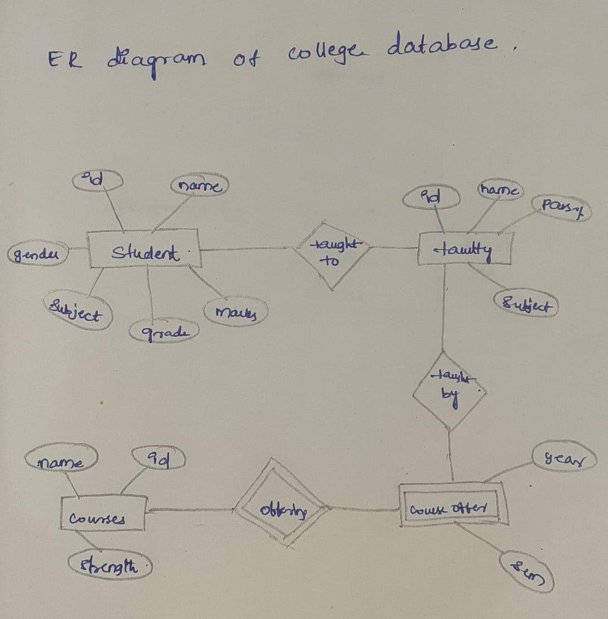

Experiment – 2

ER DIAGRAM FOR SAILOR BOAT DATABASE

**Aim**: Draw an ER diagram of sailors database.

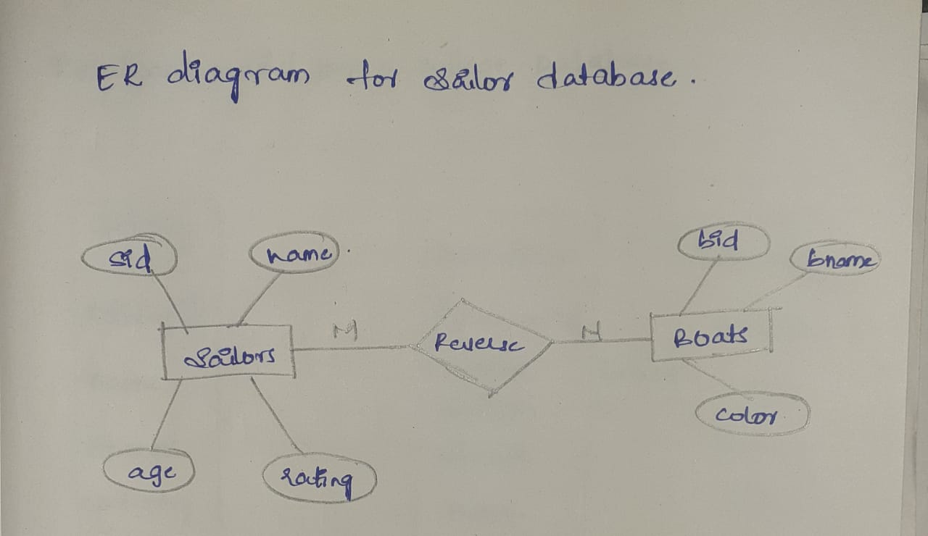

Experiment-3

RELATIONAL MODEL FOR A COLLEGE DATABASE

**Aim**: Draw a relational model for a college database

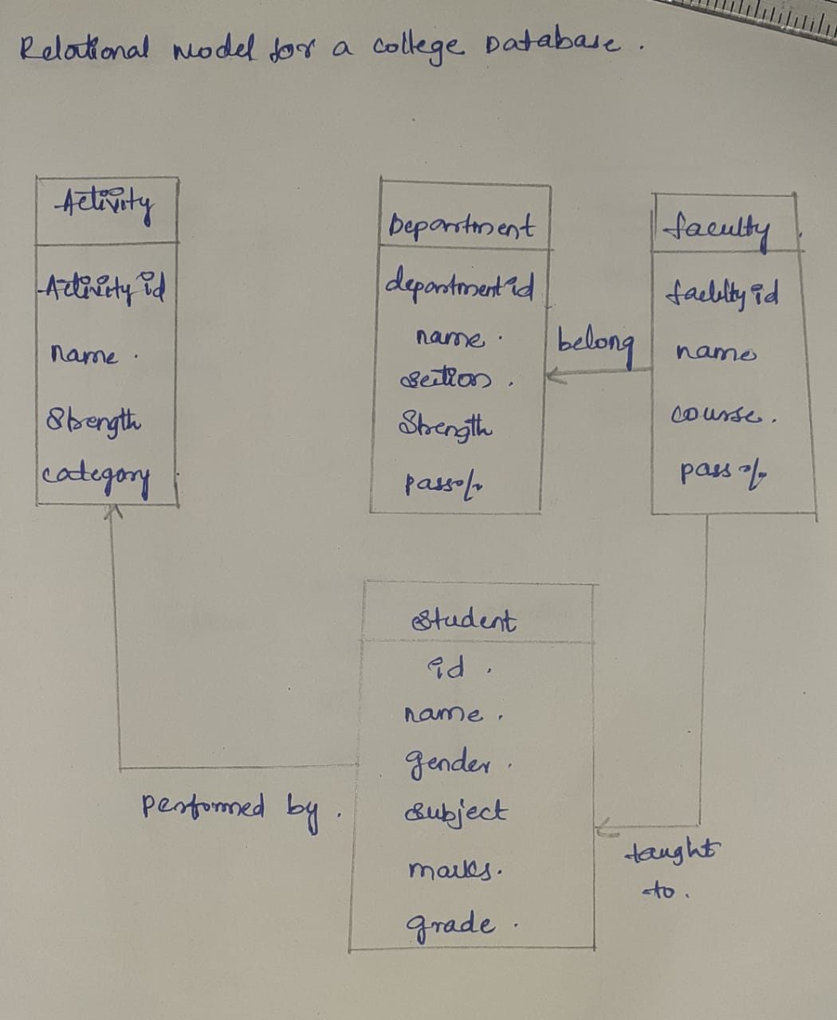

Experiment-4

RELATIONAL MODEL FOR SAILOR BOAT DATABASE

**Aim:** Draw a relational model for sailors database

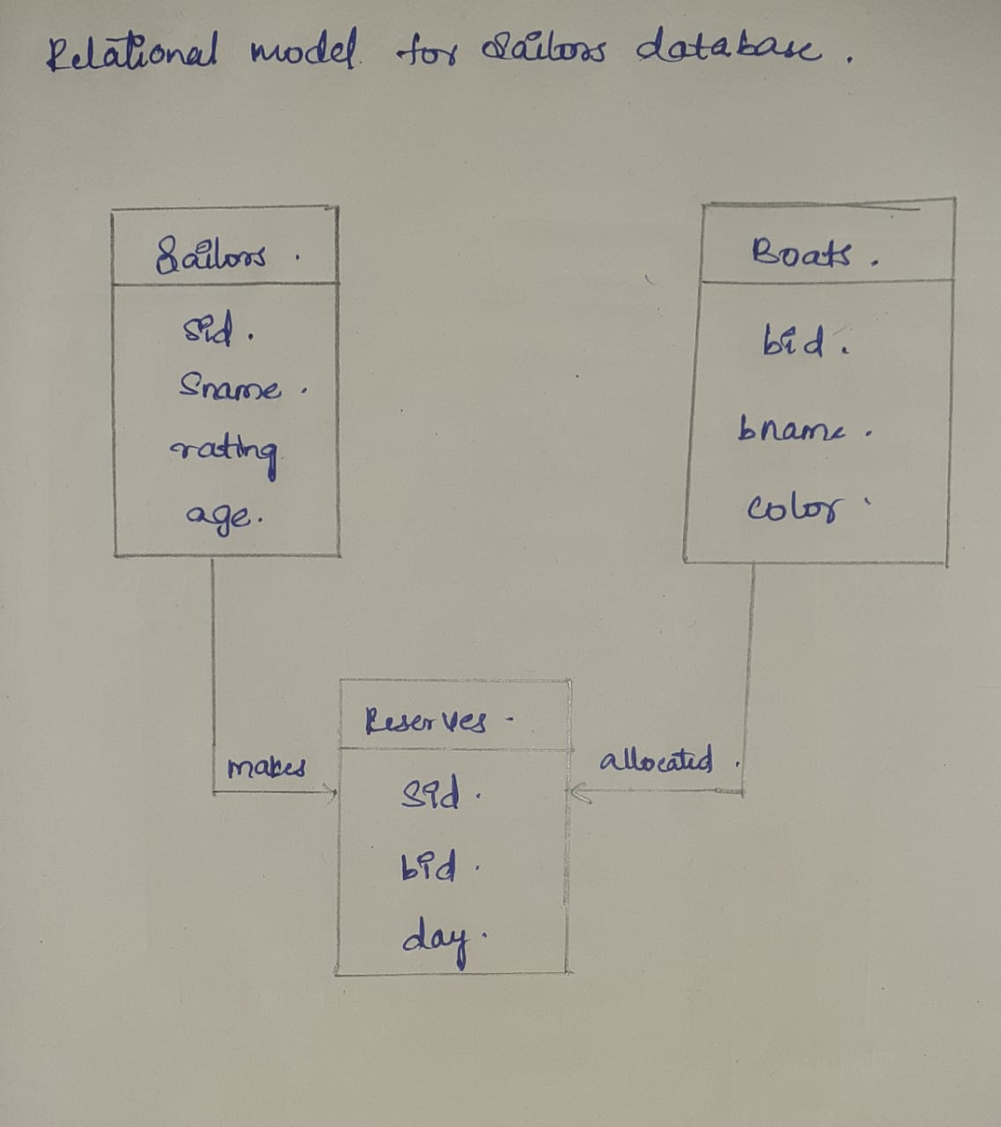

Experiment-5

1.Create schema college



2.Create table-student and attributes are studid,

studname,gender,subject,marks,grade

3.Create table-Faculty and attributes are fac_id,fac_name,course,pass percentage

4.Create table-department and attributes are dept_no, dept_name,section,no of students,pass percentage

5.Create table-Activity and attributes are act_id,act_name,no of students opted ,category of activity

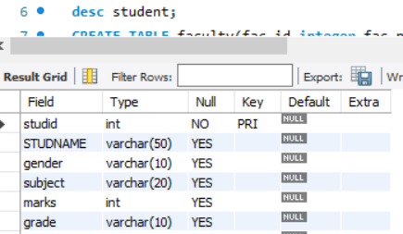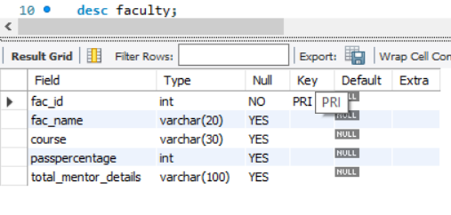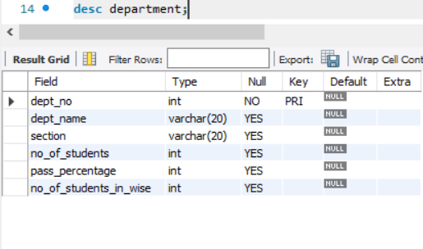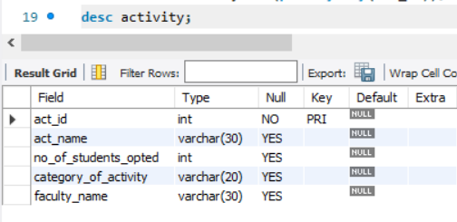

1.Add address in student table,change the datatype size for student name and make studid as primary key



2.Add faculty total mentor details,make fac_id as primary key



3.Add no of students in wise and make dept no as primary key



4.Add faculty name and change the size of act_name and act_id as primary key

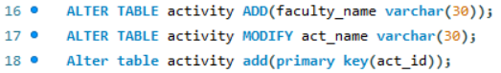

Experiment-6

1.Insert 5 instances in each table and display the result

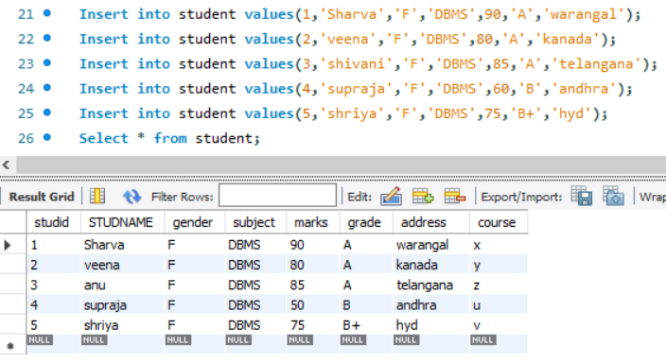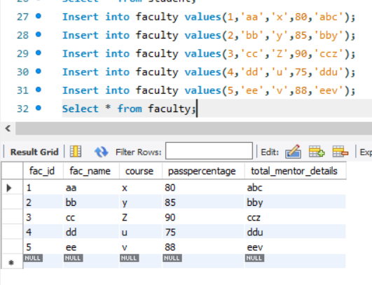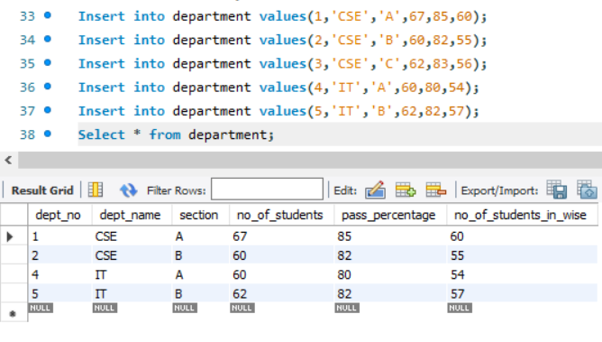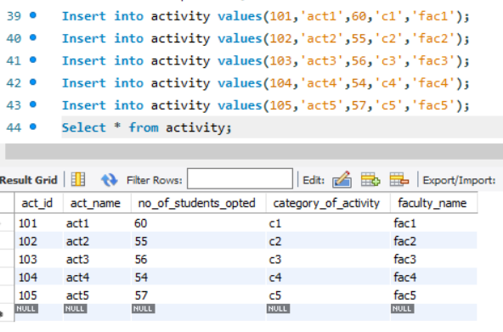

2.Display student no,marks from student table

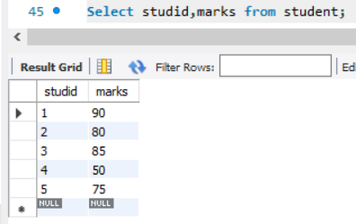

3.Display faculty no,name from faculty table

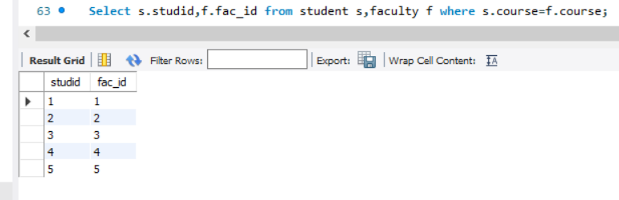

Experiment-7

1.Display 1 to 5 students details

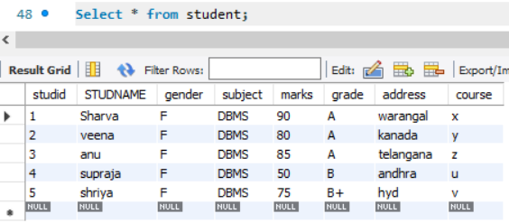

2.Display who got grade A

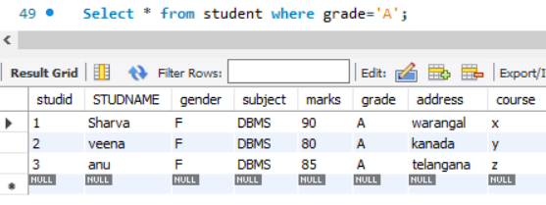

3.Display whose mark is less than 50

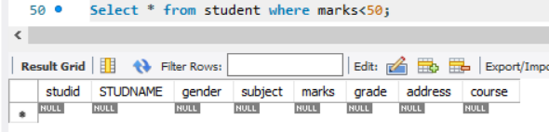

4.Display student id and name

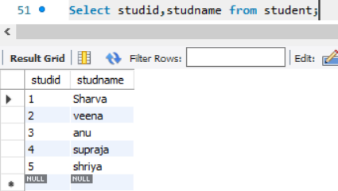

5.Display the student id and name whose mark is 50 to 60 and female

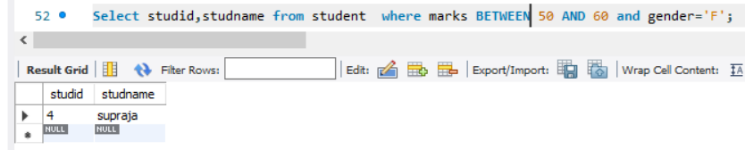

6.Display the list of students who gets greater than 70

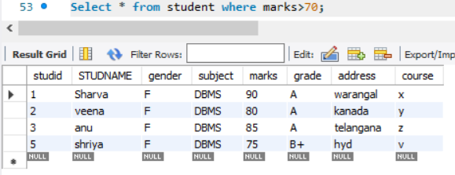

7.delete the failure students

Display complete table

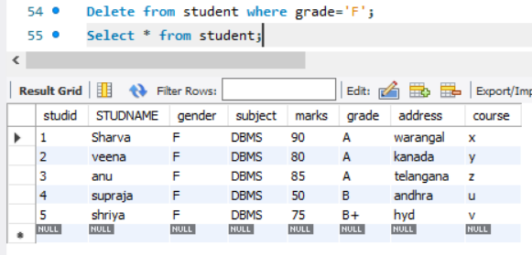

8.display activity id,name using object

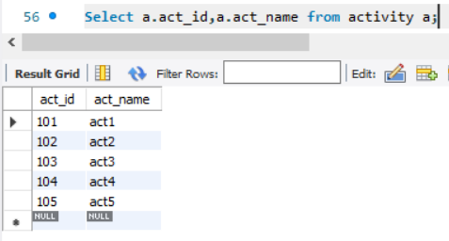

9.Add course to student table then insert values.display student id,faculty id using course name condition with object

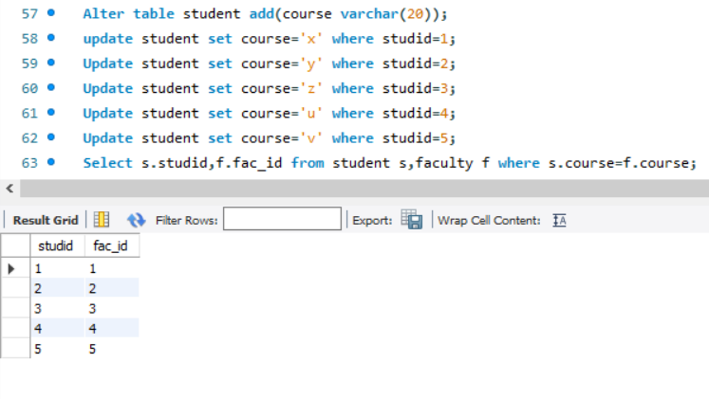

Activity-5

1.change mark to 50 whose id is 4



2.change name whose id is 3



3.change activity name whose id between 5 to 7

4.change department section to A whose id is less than 5 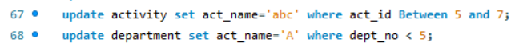

5.delete row who has id=3

6.select student name and activity name from student and activity table

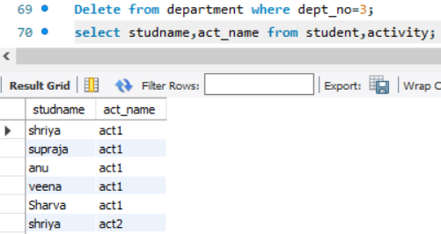

7.Select student name and mark from student and faculty name from faculty

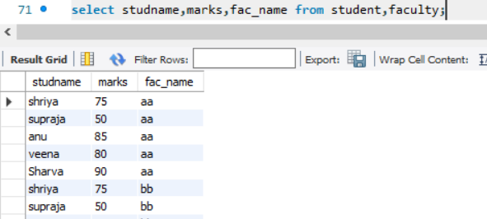

Activity-6

1.select department starts from ‘c’and faculty name ends with ‘’

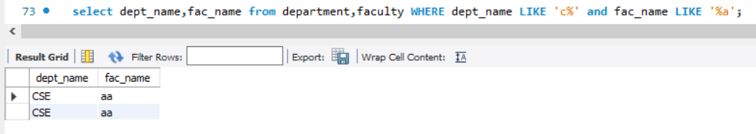

2.select activity having character between ‘ck’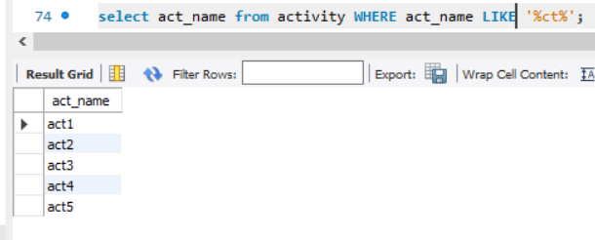

3.display students list descending order of student id

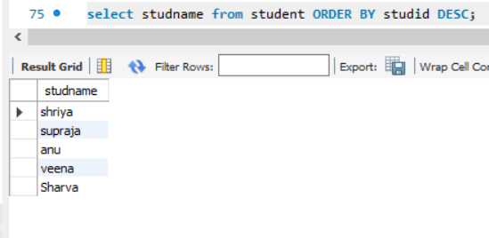

4.display faculty name ascending order

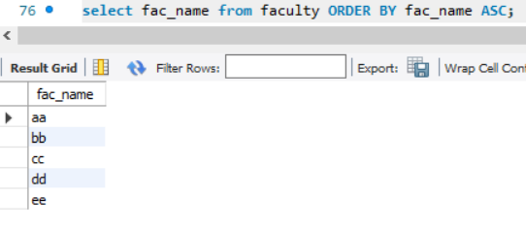

5.display students list based on grade

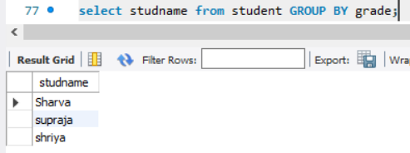

6.display students having grade a using group by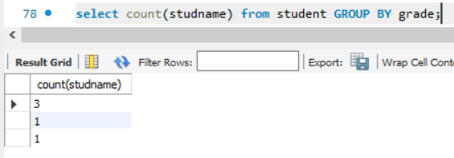

7.group by faculty id and display

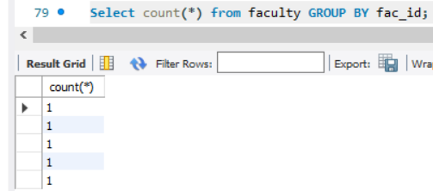

8.display the students list whose grade is A using having

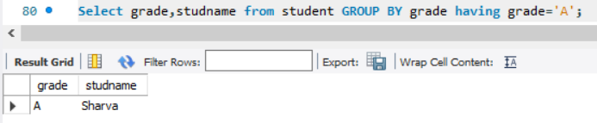

9.display the faculty list who are teaching subject pps

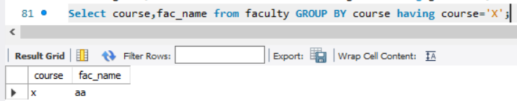

10.Apply aggregate functions in students marks-min,max,sum,count,avg

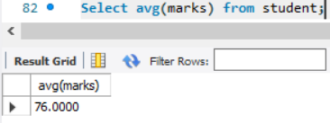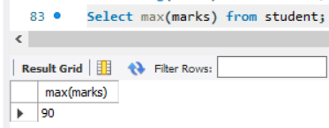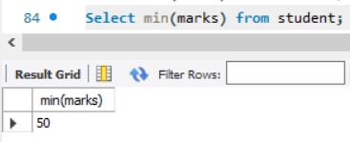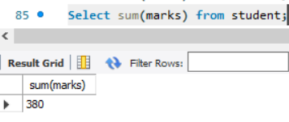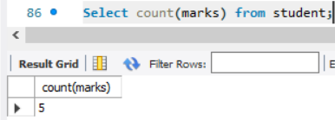

Experiment-8

1.Create tables for sailor, boat and reserves

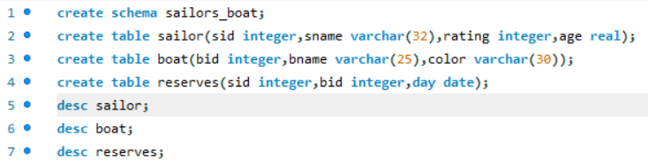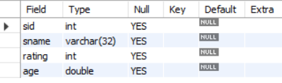

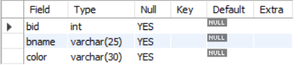

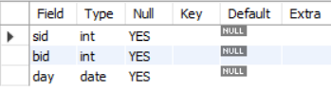

2.Insert 5 values each table

Sailor table:

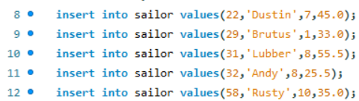

Boat table:

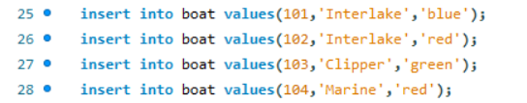

Reserves table:

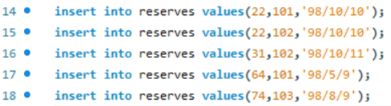

3.Display all records



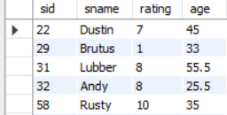



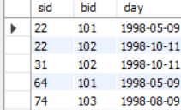



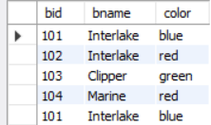

4.find the names and ages of all the sailors

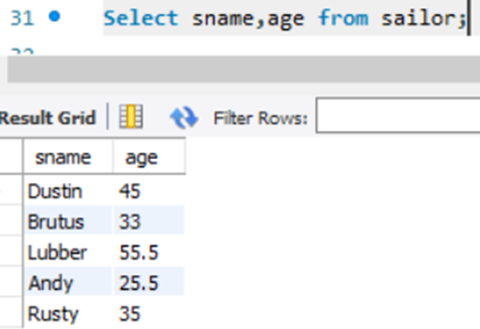

5.find all sailors with a rating above 8

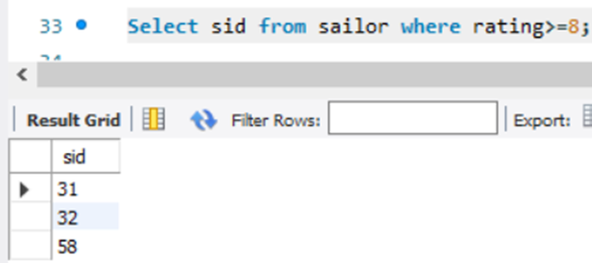

6.find sailors name with a rating above 7 & age above 25

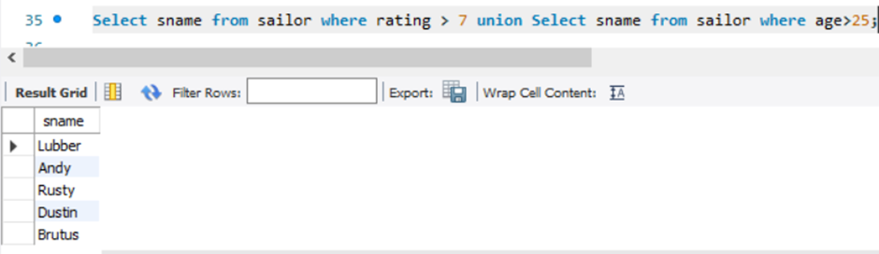

7.display all the names and colors of the boat

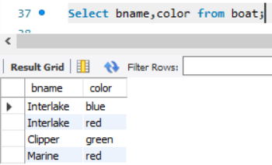

8.Find all the boats with red color

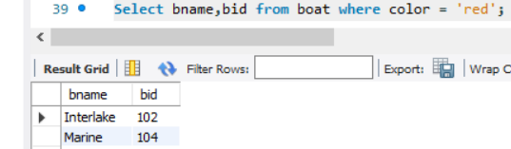

9.find the names of sailors who have reserved boat number 101

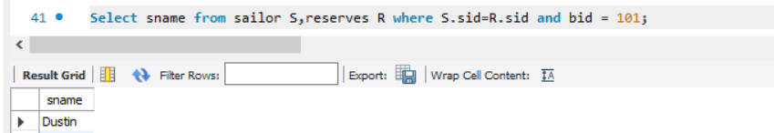

10.find the sids of sailor who have reserved pink boat

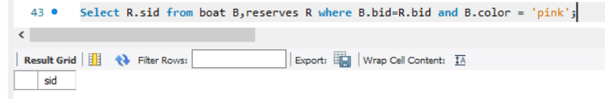

11.find names of sailors who have reserved red boat

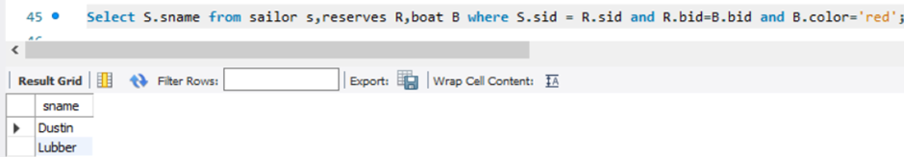

12.find the colors of boats reserved by some name (provide any name in the table)

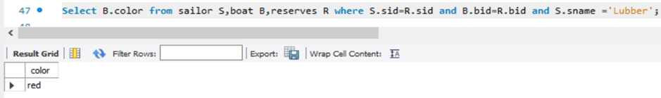

13.find names of the sailors who have reserved at least one boat

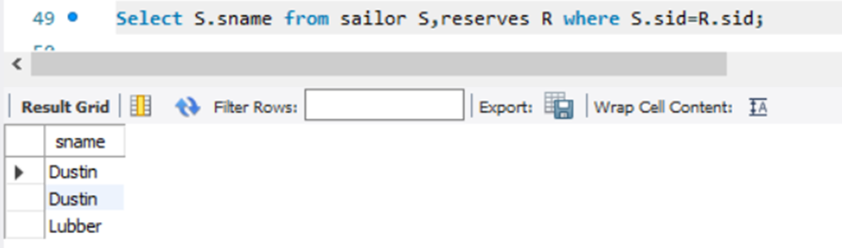

14.find names of the sailors who have reserved two different boats

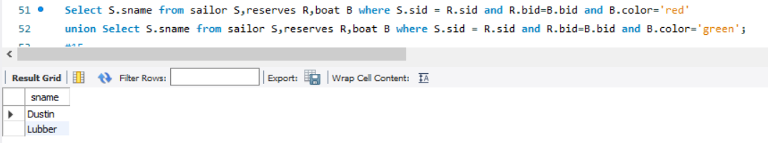

15.find the names of sailors who have reserved a red or a green boat

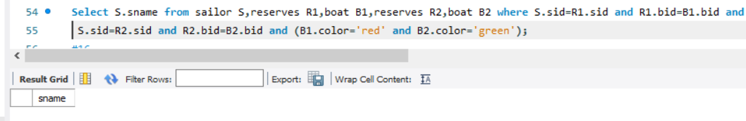

16.find the names of sailors who have reserved both a red and a green boat

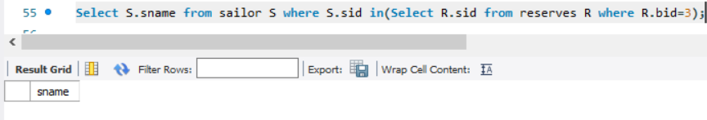

17.find the names of sailors who have reserved boat 3

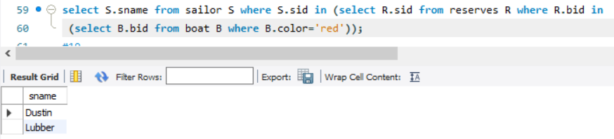

19.find the names of sailors who have not reserved a red boat(nq)

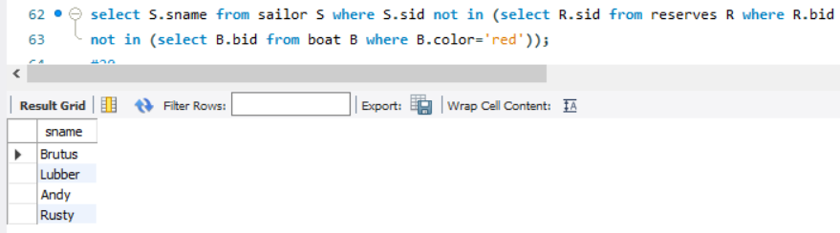

20.find the names of sailors who have reserved boat number 103(exists)

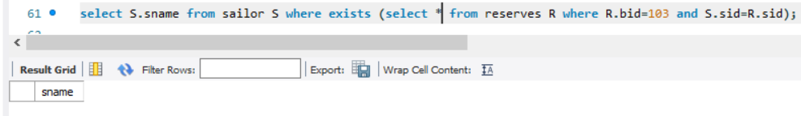

21.find sailors whose rating is better than some sailor called name

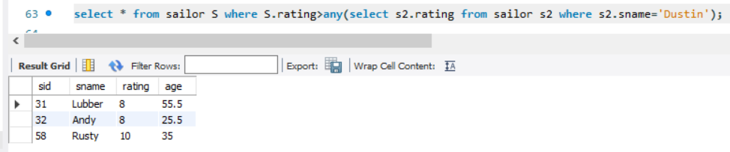

22.find sailors whose rating is better than every sailor called name

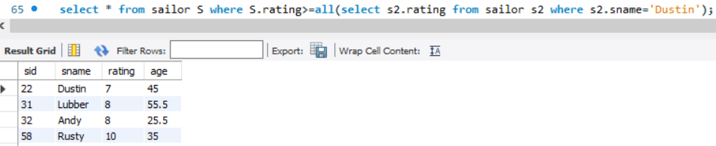

23.find the sailors with the highest rating

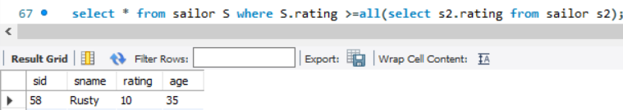

24.find the average age of all sailors

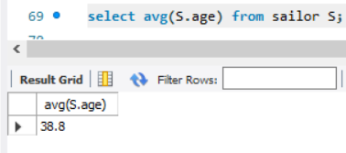

25.find the average age of sailors with a rating of 10

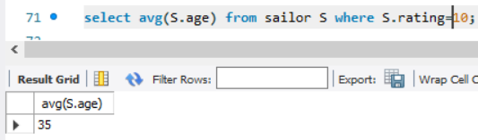

26.count the number of sailors

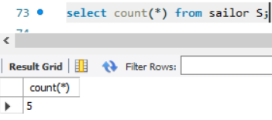

27.count the number of different sailor ratings



28.find the name and age of the oldest sailor

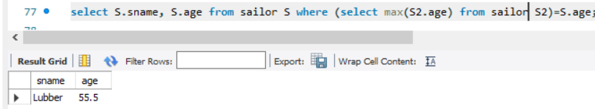

29.find the names of sailors who are older than the oldest sailor with a rating of 10

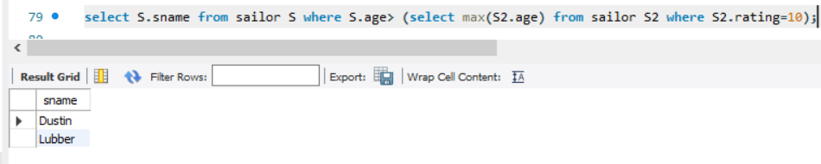

30.find the age of the youngest sailor for each rating level

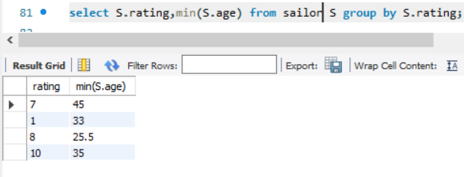

31.find the age of the youngest sailor who is eligible to vote (i.e., is at least 18 years old) for each rating level with at least two such sailors

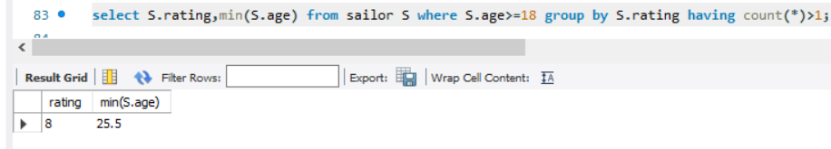

32.for each red boat, find the number of reservations for this boat

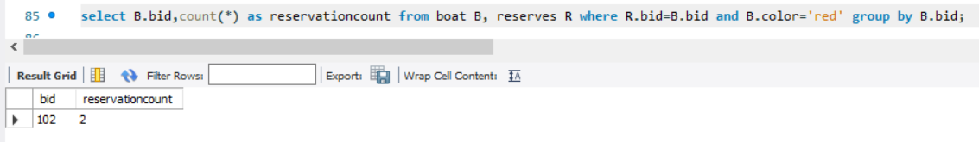

33.find all sailors name according to names

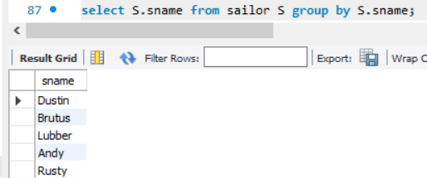

34.find all sailors details according to rating

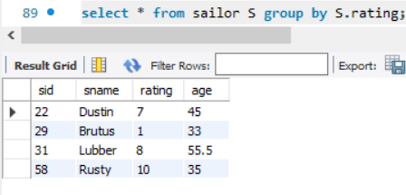

35. find all sailors details according to rating (highest first), if ratings are same then according to age

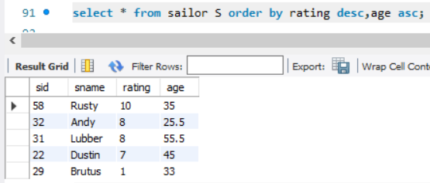

Experiment-9

Views



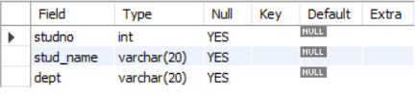





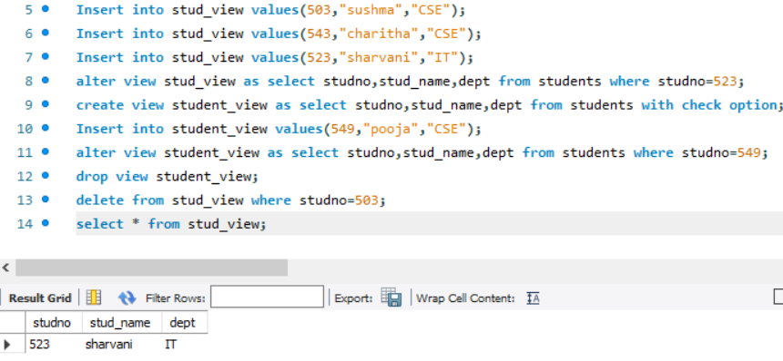

Experiment-10

Triggers

1. Create a table with attribute sname, and another table with newname



2.Create a trigger to insert into second table before inserting in first table.



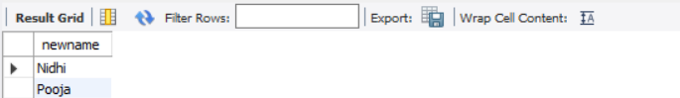

2.Create a table for account details with attributes account number and an amount.

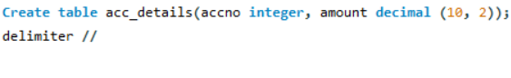

3.Create a trigger to check if amount is negative or greater than zero before inserting to table.

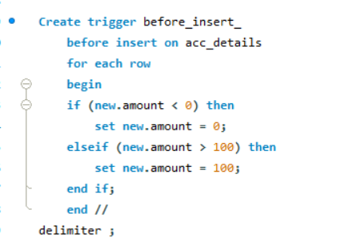

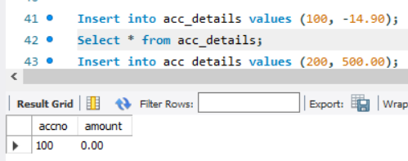

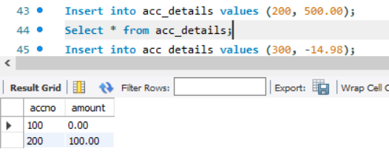

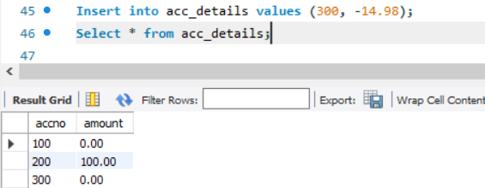

Experiment-11

Procedures

* Create a table with attributes students and marks
* Insert values into the table.

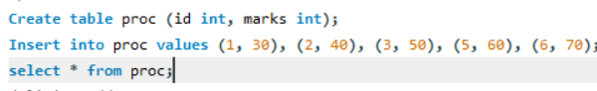

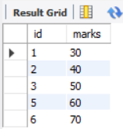

* Create a procedure to get the merit students (marks > 50).
* Create a procedure to get marks of a given id (using in).

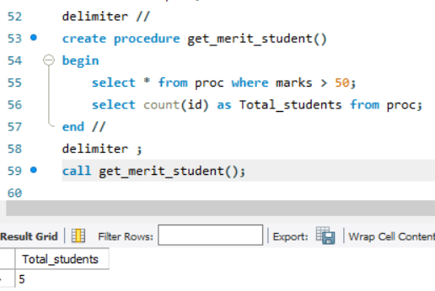

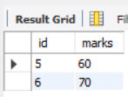

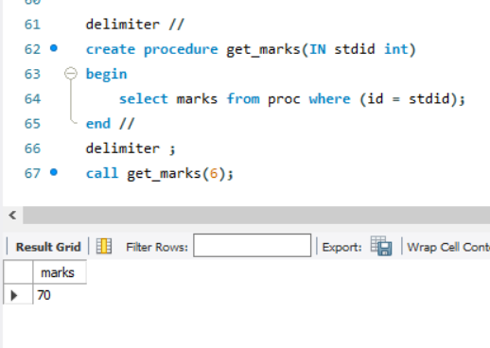

Experiment-12

Cursors

* Create a table with attributes students and marks.
* Insert values into the table.

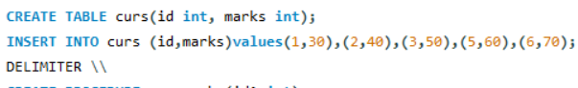

* Create a procedure, and fetch the marks of given id using a cursor.

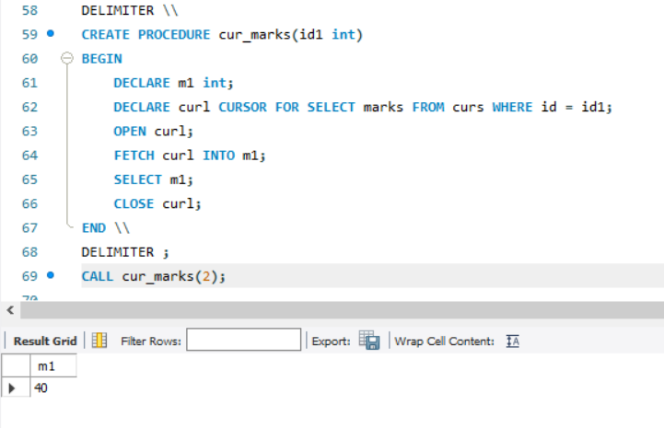

Create a procedure, and fetch the highest marks using a cursor

